Inserting RFID cards with csv file

- Go to »CRM«, »Identifications« and press »Add to stock« button:
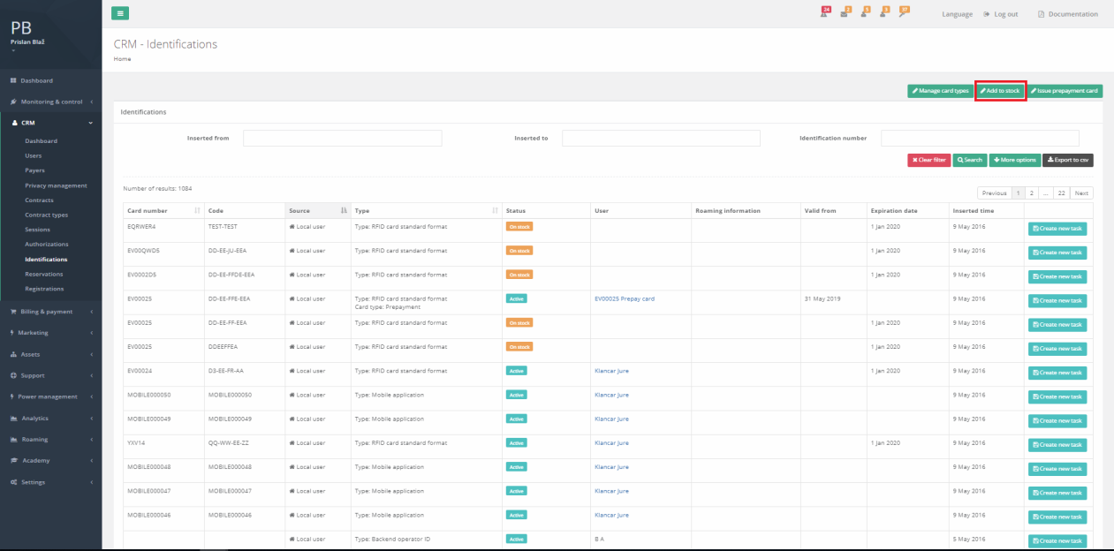
- New window will open:
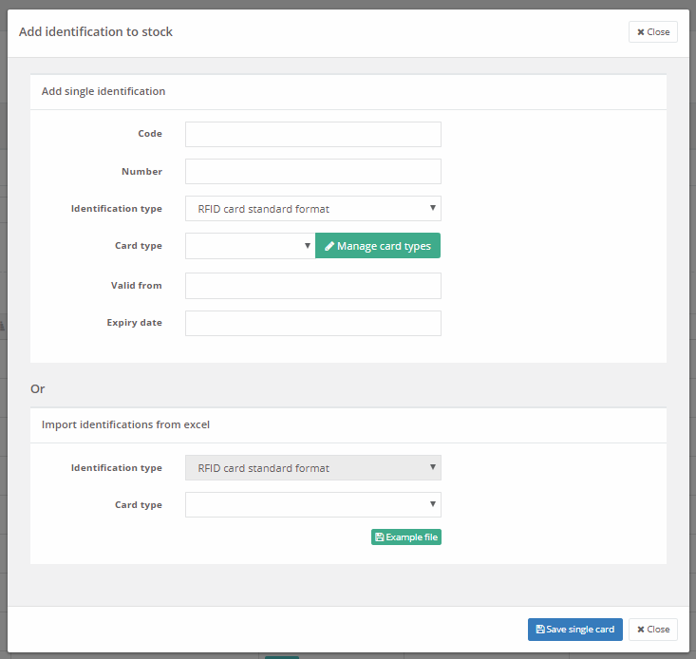
- If you press »Example file« in the section »Import identifications from excel« you will donwload csv file with the correct layout. The best way to import using the file is to simply fill the downloaded file with your RFID data. So import RFID number, code, valid from and valid to data. If valid to data column is empty RFID will validity will be unlimited.
Layout of donwloaded csv file:
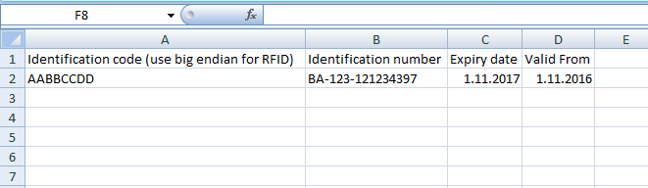
- Exchange the data in the example with your RFID data:

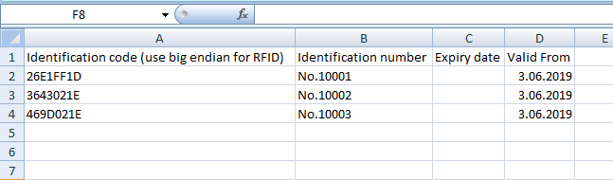

- Save the file as csv document and upload it to Ocean
- To upload it you will first have to choose card type, which is the type that will be added to every RFID card which will be uploaded with the csv file:
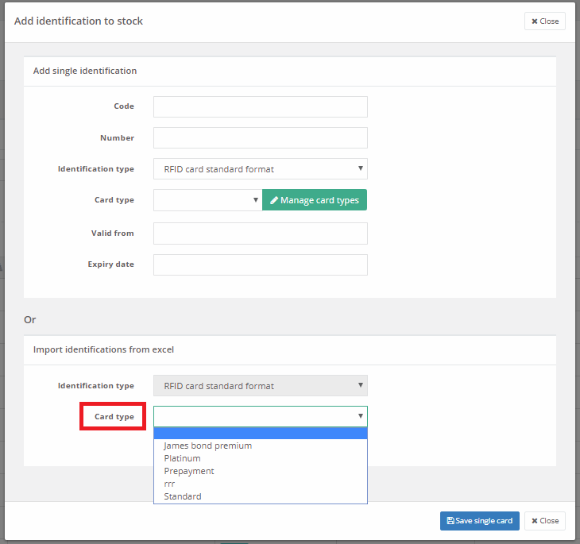
- Once you choose »Card type« new button will be shown »Proceed with import«. Click on it and select csv file that you want to upload.
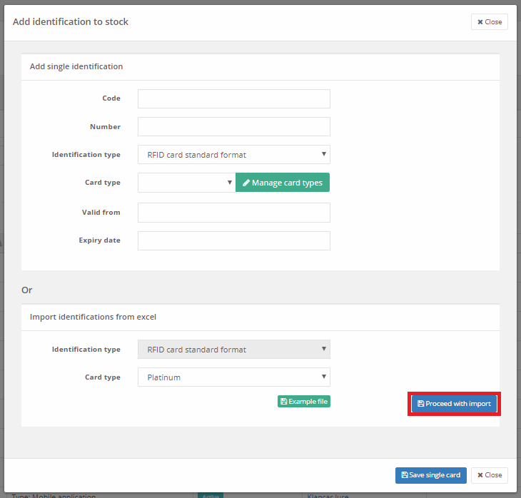
- New window will open where you can choose csv file. Once choosen you can upload it by pressing the upload button.
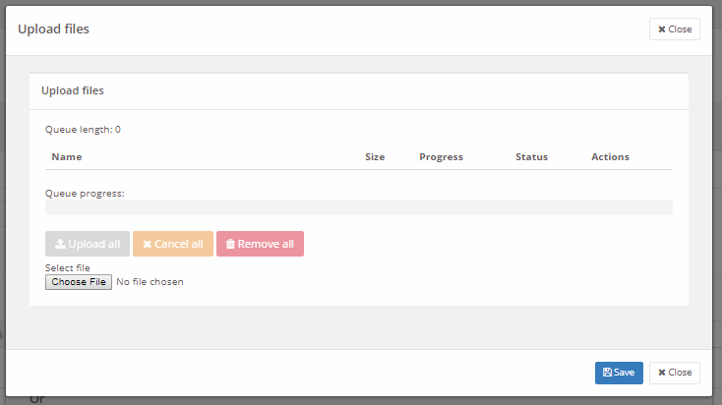
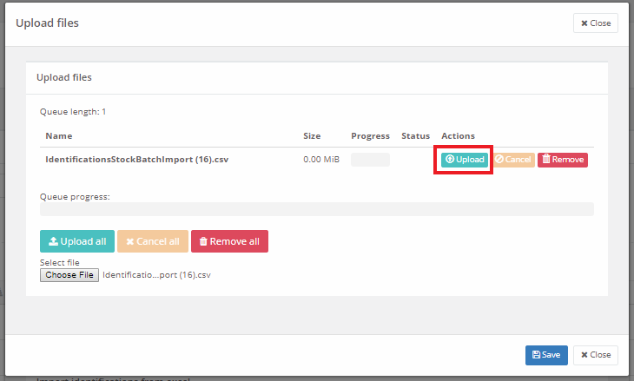

- If the operation is succesfull you will get Success message:
- If not you will get description what is the issue.

